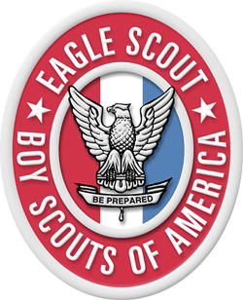

Life to Eagle Workshop

Star Scouts, Life Scouts, Parents, and Leaders interested in learning about the Eagle Rank requirements, advancement process, and Leadership Service Project are invited to attend.

Saturday, March 5

9:00 – 11:00 AM

LDS Church, 5402 Heil Avenue (near Graham Street), Huntington Beach

No need to RSVP

Questions?

Contact Jeff Campana

Pacifica District Eagle Process Chair

949-302-1050

Email: [jeff.campana@gfk.com](mailto:jeff.campana@gfk.com)